Buckeye School District School Fees Protest Letter

Date\_\_\_\_\_\_\_\_\_\_\_\_\_\_\_\_\_

To: DR. David Roth, Superintendent

4560 Buckeye Rd

Shingle Springs, CA 95682

Re: Buckeye School District

This letter is to protest mitigation fees in order to meet the requirements of Government Code 66020[[1]](#footnote-1), which requires fees to be paid and a letter of protest provided. This letter states the reason for the protest.

El Dorado County is experiencing declining enrollments in student populations in most districts. This is demonstrated in the county California Basic Education Data System (CBEDS), which reflects population statistics. The Department of Finance’s latest population counts were just released for the state, and they show that El Dorado County had a population increase of 400 people in 2013. This was well below forecasted growth rates in the justification reports.

Throughout the county, building permit statistics compared to school CBEDS indicates that residential units increased while student populations decreased. The CBEDS 10 year statistical history indicates that student populations in the county are significantly down in long-term trend-lines. Spikes in student populations in grades ½ K, K and 1st, are noted. These increases are distinguishable from new growth. Increases do not coincide with increases in permits (see permit activity EDC). Furthermore, regulatory changes allow more existing resident’s children access into the classrooms by lowering age requirements into kindergarten - ½ K.

The student populations of the district indicate that space is available in the classrooms. Mitigation fees are based on mitigating impacts from population growth. The CBEDS for the district indicate declining student populations over time. Therefore, no impacts have been generated from population growth, so the fee is unjustified.

The justification report is critically flawed for the following reasons.

1. A SIGNIFICANT NUMBER OF VACANT PARCELS REMAINING IN THE DISTRICT ARE AGE RESTRICTED DEVELOPMENTS. (This is significant information and no calculation included.)
2. CBEDS INDICATE TREND-LINE DECREASES IN STUDENT POPULATIONS IN THE DISTRICT.
3. STUDENT POPULATION INCREASES FROM REGULATORY CHANGES (½ K) INCREASE STUDENT POPULATIONS, BUT ARE NOT CAUSED BY NEW DEVELOPMENT.
4. SEVEN YEARS OF HISTORICAL CBEDS SHOWS LESS STUDENTS CURRENTLY IN THE DISTRICT THAN

IN 2007.

The Buckeye Justification Report is flawed in forecasting increased student population growth that triggers the need for mitigation fees. Buckeye’s student populations have declined over a 7-year trend, and as such, there are no impacts evidenced. Growth mitigation fees have been collected while student populations decrease. Impact fees are not justified as a result and the nexus is broken. I believe the Mitigation Fee Act (government code 66000 – 66020) has been violated as a consequence.

The Buckeye justification report uses data from 2000 for population forecasting when newer available data conflicts with the older higher growth rates. Six hundred eighty-nine residential units were built from 2007 through 2013 and the district lost 16 students. The student yield factor for the Buckeye District is therefore a negative .02 per residential unit. The need for mitigation is not demonstrated in student yield counts. No nexus is therefore established. The study uses metropolitan demographic student growth rates when the rural Buckeye District includes a unique and distinguishable student population.

BUCKEYE DISTRICT CBEDS RETROSPECT (State Office of Education)

|  |  |  |  |  |  |  |
| --- | --- | --- | --- | --- | --- | --- |
| 2007-2008 | 2008-2009 | 2009-2010 | 2010-2011 | 2011-2012 | 2012-2013 | 2013-2014 |
| 5,101 | 5,100 | 5,075 | 5,073 | 4,997 | 5,099 | 5,085 |

Forecasting growth from declining student populations is a difficult thing. However, the majority of the El Dorado county school districts accomplish this - even with 10 years of declining populations in most districts. It should be noted that Buckeye District is among many surrounding districts with declining student populations.

We protest the fees on the grounds that space is available for students in the district. The student population growth forecasts are dramatically overstated and are contrary to reality (CBEDS). An increase in student populations caused by adding new student populations from existing residents is not new development’s impacts. Therefore, they are not attributable to new growth’s impacts - ½ K.

There is a 66%/34% split between the elementary and high school district for *Mello Roos* taxes within the Buckeye District. No calculation of *Mello Roos* funding is apparent in the Buckeye Justification Report. No calculation is made for age restricted developments effect on the fee.

We requested claim forms from the County Office of Education but no claim form was provided by the district. A check in the amount of \_\_\_\_\_\_\_\_\_\_\_\_\_\_\_\_\_\_\_\_\_\_\_ for impact fees is attached with this protest letter. This letter is signed under the penalty of perjury and all information herein is true and correct to the best of my knowledge.

Signed\_\_\_\_\_\_\_\_\_\_\_\_\_\_\_\_\_\_\_\_\_\_\_\_\_\_\_\_\_\_\_\_\_\_\_

Date\_\_\_\_\_\_\_\_\_\_\_\_\_\_\_\_\_\_\_\_\_\_\_\_\_\_\_\_\_\_\_\_\_\_\_\_\_

Address of project\_\_\_\_\_\_\_\_\_\_\_\_\_\_\_\_\_\_\_\_\_\_\_\_\_\_

\_\_\_\_\_\_\_\_\_\_\_\_\_\_\_\_\_\_\_\_\_\_\_\_\_\_\_\_\_\_\_\_\_\_\_\_\_\_\_\_\_

APN\_\_\_\_\_\_\_\_\_\_\_\_\_\_\_\_\_\_\_\_\_\_\_\_\_\_\_\_\_\_\_\_\_\_\_\_\_\_

Check Number\_\_\_\_\_\_\_\_\_\_\_\_\_\_\_\_\_\_\_\_\_\_\_\_\_\_\_\_\_

Exhibit A

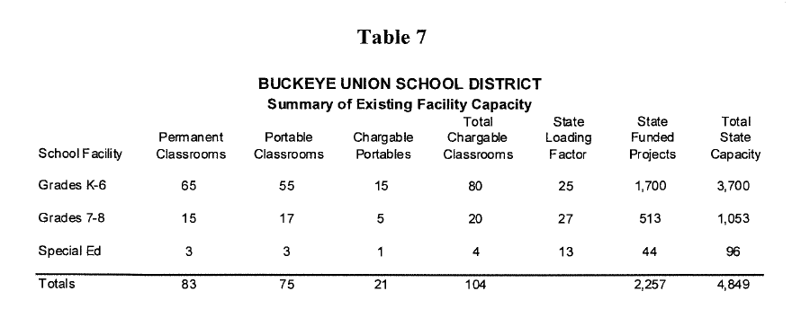

Exhibit B

Macintosh HD:Users:jeffreyerskine:Desktop:EDC_School_Enrollment_7 All Data by Year.pdf

1. 66020. (a) Any party may protest the imposition of any fees, dedications, reservations, or other exactions imposed on a

   development project, as defined in Section 66000, by a local agency by meeting both of the following requirements:

   (1) Tendering any required payment in full or providing satisfactory evidence of arrangements to pay the fee when due or

   ensure performance of the conditions necessary to meet the requirements of the imposition.

   (2) Serving written notice on the governing body of the entity, which notice shall contain all of the following information:

   (A) A statement that the required payment is tendered or will be tendered when due, or that any conditions which have been imposed are

   provided for or satisfied, under protest.

   (B) A statement informing the governing body of the factual elements of the dispute and the legal theory forming the basis for

   the protest. [↑](#footnote-ref-1)