Letter of Protest

Date\_\_\_\_\_\_\_\_\_\_\_\_\_\_

To: Robert Williams, Ed.D., Superintendent

6540 Wentworth Springs Rd

Georgetown, CA 95634

Re: Black Oak Mine Unified School District mitigation fee protest

This letter is to protest mitigation fees in order to meet the requirements of Government Code 66020[[1]](#footnote-1), which requires fees to be paid and a letter of protest provided. This letter states the reason for the protest. Since 2002, Black Oak Mine School District has incrementally lost about 600 students or 1/3rd of their enrollment. Despite these losses in students, the district provides justification reports claiming to be impacted from new development and justifying a mitigation fee.

The Black Oak Mine justification report indicates that space is available in the classrooms. Mitigation fees are based on mitigating impacts from population growth. The CBEDS for the district indicate declining student populations over time. Therefore, impacts from population growth have not happened as projected and the need for new classrooms or modernization is not supported. The mitigation fee is unjustified.

The justification report is critically flawed for the following reasons.

1) The 2014 justification report includes Table 7 (see Exhibit A), which indicates that the capacity of the K-6 student housing is 725; the capacity of the 7-8 grades is 250; and the capacity of grades 9-12 is 486. The 2014California Basic Educational Data System (CBEDS) report indicates K-6’s enrollment at 711 students; grades 7-8 having 197 students; and grades 9-12 having 454. Student populations for kindergarten, middle school, and high school have declined since 2000 and now fall well below capacity levels. This indicates space available for students in the classroom. Therefore, the fees are not justified.

2) Student projections based on new growth (see Exhibit B) do not take into account the decline in student populations each year over the past 14 years (see Exhibit C). The justification study cites metropolitan studies to support a fictitious student yield from homes in EDC.

3) All districts in the county have lost significant numbers of students (see Exhibit C). Most school districts in the county are experiencing decreasing student enrollments, many are around 2003 levels.

4) The purpose for the fee is for building new facilities for mitigating new growth. The district has a trend line of negative student population growth (see Exhibit C). Thus, there is no need for new building facilities since there are no new student populations.

Furthermore, according to Education Code 17620[[2]](#footnote-2), impact fees cannot be used for repairs on existing facilities. Impact fees can only be used for construction or reconstruction of buildings.

Please be advised that payment is made in full for the mitigation fee in the amount of \_\_\_\_\_\_\_\_\_\_\_\_\_\_\_ and is paid under protest. All information contained here is true and to the best know of my knowledge accurate and correct. This document is signed under penalty of perjury.

Signed\_\_\_\_\_\_\_\_\_\_\_\_\_\_\_\_\_\_\_\_\_\_\_\_\_\_\_\_\_\_\_\_\_\_\_

Date\_\_\_\_\_\_\_\_\_\_\_\_\_\_\_\_\_\_\_\_\_\_\_\_\_\_\_\_\_\_\_\_\_\_\_\_\_

Address of project\_\_\_\_\_\_\_\_\_\_\_\_\_\_\_\_\_\_\_\_\_\_\_\_\_\_

\_\_\_\_\_\_\_\_\_\_\_\_\_\_\_\_\_\_\_\_\_\_\_\_\_\_\_\_\_\_\_\_\_\_\_\_\_\_\_\_\_

APN\_\_\_\_\_\_\_\_\_\_\_\_\_\_\_\_\_\_\_\_\_\_\_\_\_\_\_\_\_\_\_\_\_\_\_\_\_\_

Check Number\_\_\_\_\_\_\_\_\_\_\_\_\_\_\_\_\_\_\_\_\_\_\_\_\_\_\_\_\_

Exhibit A

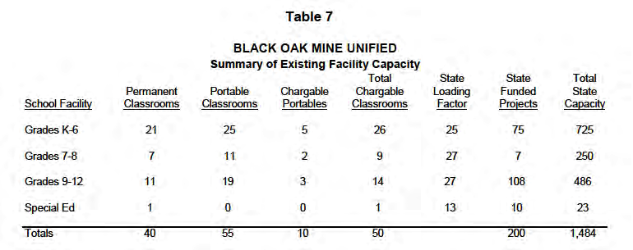

Exhibit B

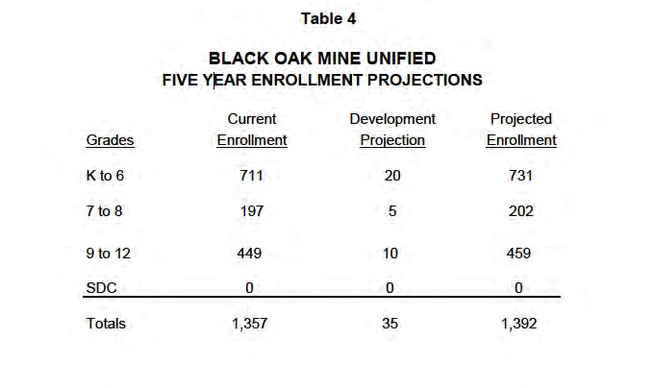

Exhibit C

Macintosh HD:Users:jeffreyerskine:Desktop:EDC_School_Enrollment_7 All Data by Year.pdf

1. Government Code 66020 (a) Any party may protest the imposition of any fees, dedications, reservations, or other exactions imposed on a

   development project, as defined in Section 66000, by a local agency by meeting both of the following requirements:

   (1) Tendering any required payment in full or providing satisfactory evidence of arrangements to pay the fee when due or

   ensure performance of the conditions necessary to meet the requirements of the imposition.

   (2) Serving written notice on the governing body of the entity, which notice shall contain all of the following information:

   (A) A statement that the required payment is tendered or will be tendered when due, or that any conditions which have been imposed are

   provided for or satisfied, under protest.

   (B) A statement informing the governing body of the factual elements of the dispute and the legal theory forming the basis for

   the protest. [↑](#footnote-ref-1)
2. Education Code 17620 (a)(3) For purposes of this section and Section 65995 of the Government Code, "construction or reconstruction of school facilities" does not include any item of expenditure for any of the following:

   (A) The regular maintenance or routine repair of school buildings and facilities.

   (B) The inspection, sampling, analysis, encapsulation, or removal of asbestos-containing materials, except where incidental to school facilities construction or reconstruction for which the expenditure of fees or other consideration collected pursuant to this section is not prohibited.

   (C) The purposes of deferred maintenance described in Section17582. [↑](#footnote-ref-2)