Letter of Protest

Date\_\_\_\_\_\_\_\_\_\_\_\_\_\_

To: Dr. Lisa Fontana, Superintendent

6862 Mt. Aukum Road

Somerset, CA 95684

Re: Pioneer Union School District Protest Letter

This letter is to protest mitigation fees in order to meet the requirements of Government Code 66020[[1]](#footnote-1), which requires fees to be paid and a letter of protest provided. This letter states the reason for the protest.

The student populations of the district indicate that space is available in the classrooms. Mitigation fees are based on mitigating impacts from population growth. The CBEDS for the district indicate declining student populations over time. Therefore, no impacts have been generated from population growth, so the fee is unjustified.

The justification report is critically flawed for the following reasons.

1) The 2013 justification report does not include a table that indicates that the capacity of the district. This is in direct contrast to all of the other district’s justification reports in El Dorado County. The 2014 California Basic Educational Data System (CBEDS) report (see Exhibit B) indicates Pioneer’s current enrollment at 330 students. Student populations have declined since 2000 and fallen by nearly 50%. We can make a fair assumption that this indicates space available for students in the classroom. Therefore, the fees are not justified.

2) Student projections based on new growth (see Exhibit A) do not take into account the decline in student populations each year over the past 14 years (see Exhibit B). Pioneer Union’s enrollment is almost 50% of 2000 levels.

3) All districts in the county have lost significant numbers of students (see Exhibit B). Almost all school districts in the county are experiencing decreasing student enrollments, which are at around 2003 levels.

4) The purpose for the fee is for building new facilities for new growth and maintenance. The district has a trend line of negative student population growth (see Exhibit B). Thus, there is no need for new building facilities since there are no new student populations.

5) Impact fees can only be collected by school districts if there is no available capacity in the district to house new students generated from new development. Districts are required to analyze their existing capacity in their justification report to determine whether there is existing capacity to house new students. Mother Lode’s 2008 justification study does not address existing capacity in the schools. Instead, the justification report makes a general statement that the district does not have the capacity for new students generated by new development. The justification study does not use statistical data to back up their argument.

Please be advised that payment is made for the fee in the amount of \_\_\_\_\_\_\_\_\_\_\_\_\_\_\_ and the mitigation fee is paid under protest. All information contained here is true and to the best know of my knowledge accurate and correct. This document is signed under penalty of perjury.

Signed\_\_\_\_\_\_\_\_\_\_\_\_\_\_\_\_\_\_\_\_\_\_\_\_\_\_\_\_\_\_\_\_\_\_\_

Date\_\_\_\_\_\_\_\_\_\_\_\_\_\_\_\_\_\_\_\_\_\_\_\_\_\_\_\_\_\_\_\_\_\_\_\_\_

Address of project\_\_\_\_\_\_\_\_\_\_\_\_\_\_\_\_\_\_\_\_\_\_\_\_\_\_

\_\_\_\_\_\_\_\_\_\_\_\_\_\_\_\_\_\_\_\_\_\_\_\_\_\_\_\_\_\_\_\_\_\_\_\_\_\_\_\_\_

APN\_\_\_\_\_\_\_\_\_\_\_\_\_\_\_\_\_\_\_\_\_\_\_\_\_\_\_\_\_\_\_\_\_\_\_\_\_\_

Check Number\_\_\_\_\_\_\_\_\_\_\_\_\_\_\_\_\_\_\_\_\_\_\_\_\_\_\_\_\_

Exhibit A

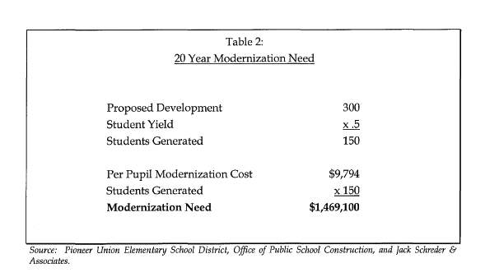

Exhibit B

Macintosh HD:Users:jeffreyerskine:Desktop:EDC_School_Enrollment_7 All Data by Year.pdf

1. 66020. (a) Any party may protest the imposition of any fees, dedications, reservations, or other exactions imposed on a

   development project, as defined in Section 66000, by a local agency by meeting both of the following requirements:

   (1) Tendering any required payment in full or providing satisfactory evidence of arrangements to pay the fee when due or

   ensure performance of the conditions necessary to meet the requirements of the imposition.

   (2) Serving written notice on the governing body of the entity, which notice shall contain all of the following information:

   (A) A statement that the required payment is tendered or will be tendered when due, or that any conditions which have been imposed are

   provided for or satisfied, under protest.

   (B) A statement informing the governing body of the factual elements of the dispute and the legal theory forming the basis for

   the protest. [↑](#footnote-ref-1)