Letter of Protest

Date\_\_\_\_\_\_\_\_\_\_\_\_\_\_

To: Wendy Neade, Superintendent

3171 Pleasant Valley Rd

Placerville, CA 95667

Re: Gold Oak School District

This letter is to protest mitigation fees in order to meet the requirements of Government Code 66020[[1]](#footnote-1), which requires fees to be paid and a letter of protest provided. This letter states the reason for the protest.

The student populations of the district indicate that space is available in the classrooms. Mitigation fees are based on mitigating impacts from population growth. The CBEDS for the district indicate declining student populations over time. Therefore, no impacts have been generated from population growth, so the fee is unjustified.

The justification report is critically flawed for the following reasons.

1) The 2006 justification report includes Figure 1 (see Exhibit A), which indicates that the capacity of Gold Oak School District is 728. The 2014 California Basic Educational Data System (CBEDS) report indicates 2013-2014 enrollment is 464. This indicates space available for students in the classroom. Therefore, the fees are not justified.

2) The Gold Oak 2006 school justification study has been reused even though they have new data negating their 2006 findings that, "this figure indicates the District will exceed its facility capacity of 728 K-8th grade students beginning with the 2006-2007 school year and will continue to do so through the 2010-2011 school year". This also negates the five year required update as stated in the Government Code 66001(d)(1)[[2]](#footnote-2). El Dorado building permits are averaging well below forecasted levels for the whole county and the population growth for EDC in 2013 was 404 people according to the Department of Finance (June, 2014). Things have changed dramatically over the last 8 years.

3) All districts in the county have lost significant numbers of students (see Exhibit B). Almost all school districts in the county are experiencing decreasing student enrollments, which are at around 2003 levels.

4) The purpose for the fee is for building new facilities for new growth and maintenance. The district has a trend line of negative student population growth (see Exhibit B). Thus, there is no need for new building facilities since there are no new student populations.

Please be advised that payment is made for the fee in the amount of \_\_\_\_\_\_\_\_\_\_\_\_\_\_\_ and the mitigation fee is paid under protest. All information contained here is true and to the best know of my knowledge accurate and correct. This document is signed under penalty of perjury.

Signed\_\_\_\_\_\_\_\_\_\_\_\_\_\_\_\_\_\_\_\_\_\_\_\_\_\_\_\_\_\_\_\_\_\_\_

Date\_\_\_\_\_\_\_\_\_\_\_\_\_\_\_\_\_\_\_\_\_\_\_\_\_\_\_\_\_\_\_\_\_\_\_\_\_

Address of project\_\_\_\_\_\_\_\_\_\_\_\_\_\_\_\_\_\_\_\_\_\_\_\_\_\_

\_\_\_\_\_\_\_\_\_\_\_\_\_\_\_\_\_\_\_\_\_\_\_\_\_\_\_\_\_\_\_\_\_\_\_\_\_\_\_\_\_

APN\_\_\_\_\_\_\_\_\_\_\_\_\_\_\_\_\_\_\_\_\_\_\_\_\_\_\_\_\_\_\_\_\_\_\_\_\_\_

Check Number\_\_\_\_\_\_\_\_\_\_\_\_\_\_\_\_\_\_\_\_\_\_\_\_\_\_\_\_\_

Exhibit A

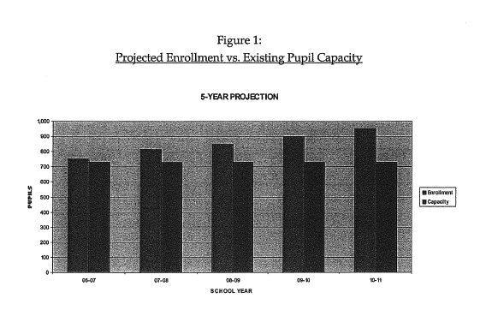

Exhibit B

Macintosh HD:Users:jeffreyerskine:Desktop:EDC_School_Enrollment_7 All Data by Year.pdf

1. 66020. (a) Any party may protest the imposition of any fees, dedications, reservations, or other exactions imposed on a

   development project, as defined in Section 66000, by a local agency by meeting both of the following requirements:

   (1) Tendering any required payment in full or providing satisfactory evidence of arrangements to pay the fee when due or

   ensure performance of the conditions necessary to meet the requirements of the imposition.

   (2) Serving written notice on the governing body of the entity, which notice shall contain all of the following information:

   (A) A statement that the required payment is tendered or will be tendered when due, or that any conditions which have been imposed are

   provided for or satisfied, under protest.

   (B) A statement informing the governing body of the factual elements of the dispute and the legal theory forming the basis for

   the protest. [↑](#footnote-ref-1)
2. 66001(d)(1). For the fifth fiscal year following the first deposit into the account or fund, and every five years thereafter, the local agency shall make all of the following findings with respect to that portion of the account or fund remaining unexpended, whether committed or uncommitted:

   (A) Identify the purpose to which the fee is to be put.

   (B) Demonstrate a reasonable relationship between the fee and the purpose for which it is charged.

   (C) Identify all sources and amounts of funding anticipated to complete financing in incomplete improvements identified in paragraph

   (2) of subdivision (a).

   (D) Designate the approximate dates on which the funding referred to in subparagraph (C) is expected to be deposited into the appropriate account or fund.

   (2) When findings are required by this subdivision, they shall be made in connection with the public information required by subdivision (b) of Section 66006. The findings required by this subdivision need only be made for moneys in possession of the local agency, and need not be made with respect to letters of credit, bonds, or other instruments taken to secure payment of the fee at a future date. If the findings are not made as required by this subdivision, the local agency shall refund the moneys in the account or fund as provided in subdivision (e). [↑](#footnote-ref-2)