Letter of Protest

Date\_\_\_\_\_\_\_\_\_\_\_\_\_\_

To: Erik Bonniksen, Superintendent

3060 Snows Road

Camino, CA 95709

Re: Camino Union School District

This letter is to protest mitigation fees in order to meet the requirements of Government Code 66020[[1]](#footnote-1), which requires fees to be paid and a letter of protest provided. This letter states the reason for the protest.

Our review of historical attendance and capacity records indicates that space is available in the classrooms. Mitigation fees are based on mitigating impacts from new development. The CBEDS for the district indicate a 10 year declining student populations excepting in the last few years. However, the impacts (increased student population) have been generated from existing homes and commercial properties, so the fee is unjustified. Upon examination of building permit records we find declining permit numbers for the past 8 years. IN 2001, the student population of Camino was 592. CBEDS indicate 2014/2014 is 544 students.

From 2009/2010 school year to 2013/14 Camino gained 126 students but according to EDC permit records, only 9 new homes were built in this same time.

The justification report is critically flawed for the following reasons.

1) EDC Building Department records show nine new single-family residential units have been built in the Camino School District **since 2009**. However, Camino has grown by almost 126 students since then. According to Exhibit A (taken from Camino’s Justification Study completed in 2013), single-family residential units yield .5 students per house. Therefore, since 9 new residential units have been built, the student yield from these residential units is 4.5 students. This means that around 115 new students came from existing residential units.

According to Government Code 66001(g), new development shall not pay for existing deficiencies[[2]](#footnote-2). Therefore, the "new" students that came in to Camino School District are not caused from new development. NO impact fee is justified for 4.5 students when the district housed 592 students in 2001 and is now 48 students below 2001 levels.

It should be noted that in most EDC districts a negative student yield rate is apparent. For example, the Buckeye District demonstrated 744 permits but lost 15 students in that same period. Camino's student yield rate from 2007 to current is minus .11 (Since 2007, Camino lost 2 students, divided by 18 homes equals a student yield of -.11 yield/home).

2) Justification study forecasts (see Exhibit A) do not take into account the decline in student populations since 2001 (see Exhibit B), the facility capacity that housed almost 592 students from that time (nexus and capacity inventory reports), or the actual student yields per new home. There is no mention in the justification report of nine homes being built in the previous 5 years or local demographic information.

3) School districts in the county have lost students over the past 14 years (see Exhibit B). Almost all school districts in the county are experiencing decreasing student enrollments, many of which are at around 2003 levels.

4) Classroom space is available for new students.

Please be advised that payment is made for the fee in the amount of \_\_\_\_\_\_\_\_\_\_\_\_\_\_\_ and the mitigation fee is paid under protest. All information contained here is true and to the best know of my knowledge accurate and correct. This document is signed under penalty of perjury.

Signed\_\_\_\_\_\_\_\_\_\_\_\_\_\_\_\_\_\_\_\_\_\_\_\_\_\_\_\_\_\_\_\_\_\_\_

Date\_\_\_\_\_\_\_\_\_\_\_\_\_\_\_\_\_\_\_\_\_\_\_\_\_\_\_\_\_\_\_\_\_\_\_\_\_

Address of project\_\_\_\_\_\_\_\_\_\_\_\_\_\_\_\_\_\_\_\_\_\_\_\_\_\_

\_\_\_\_\_\_\_\_\_\_\_\_\_\_\_\_\_\_\_\_\_\_\_\_\_\_\_\_\_\_\_\_\_\_\_\_\_\_\_\_\_

APN\_\_\_\_\_\_\_\_\_\_\_\_\_\_\_\_\_\_\_\_\_\_\_\_\_\_\_\_\_\_\_\_\_\_\_\_\_\_

Check Number\_\_\_\_\_\_\_\_\_\_\_\_\_\_\_\_\_\_\_\_\_\_\_\_\_\_\_\_\_

Exhibit A

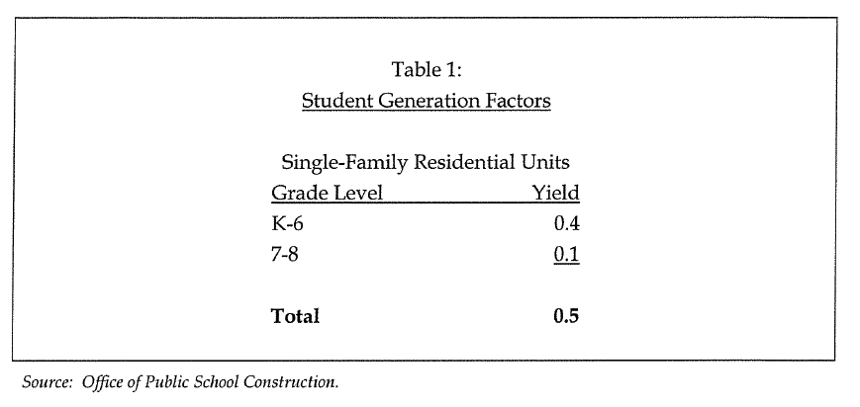

Exhibit B

Macintosh HD:Users:jeffreyerskine:Desktop:EDC_School_Enrollment_7 All Data by Year.pdf

**BUILDING PERMITS BY SCHOOL DISTRICT (SOURCE - EDC - COMMUNITY DEVELOPMENT)**

1. 66020(a) Any party may protest the imposition of any fees, dedications, reservations, or other exactions imposed on a

   development project, as defined in Section 66000, by a local agency by meeting both of the following requirements:

   (1) Tendering any required payment in full or providing satisfactory evidence of arrangements to pay the fee when due or

   ensure performance of the conditions necessary to meet the requirements of the imposition.

   (2) Serving written notice on the governing body of the entity, which notice shall contain all of the following information:

   (A) A statement that the required payment is tendered or will be tendered when due, or that any conditions which have been imposed are

   provided for or satisfied, under protest.

   (B) A statement informing the governing body of the factual elements of the dispute and the legal theory forming the basis for

   the protest. [↑](#footnote-ref-1)
2. 66001(g) A fee shall not include the costs attributable to existing deficiencies in public facilities, but may include the cost sattributable to the increased demand for public facilities reasonably related to the development project in order to

   (1) refurbish existing facilities to maintain the existing level of service or

   (2)achieve an adopted level of service that is consistent with the general plan. [↑](#footnote-ref-2)